

B. Tech – Freshmen Engineering Department
Rubrics and Evaluation Form
(A.Y 2025-26 – Trimester II)

Review: Rubrics and Evaluation Date:

Course Code & Title: 25SC1104E - FUNDAMENTALS OF WEB DEVELOPMENT

Student Name: S.Asritha Roll No: 2520040114

FWD Section No: 10 Phone No: 9959838822

Project Title: Hospital Medical Records Unified Platform

Guide Name: Dr .G .Sudhakar

GitHub Repository Link: https://github.com/asrithaswarna/MediVogue-Hospital

Deployment URL (optional): https://asrithaswarna.github.io/MediVogue-Hospital/

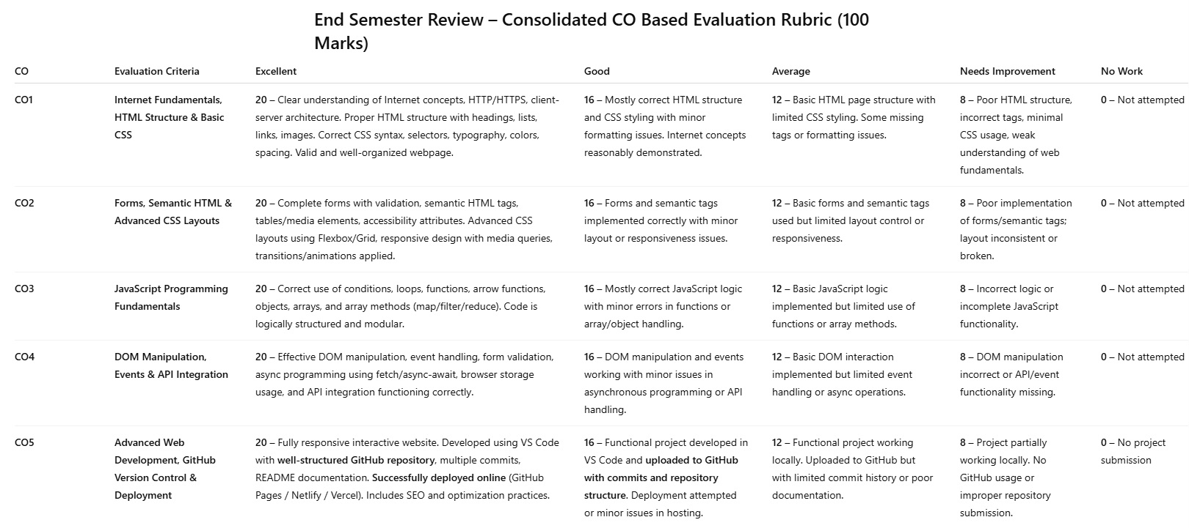



B. Tech – Freshmen Engineering Department
Rubrics and Evaluation Form
(A.Y 2025-26 – Trimester II)

Evaluation Checklist:

Course Outcome | Evaluation Focus | Excellent (20) | Good (16) | Average (12) | Needs Improvement (8)
CO1 | HTML Structure, Internet Concepts, Basic CSS | ☐ | ☐ | ☐ | ☐
CO2 | Forms, Semantic HTML, Responsive CSS Layout | ☐ | ☐ | ☐ | ☐
CO3 | JavaScript Logic, Functions, Arrays, Objects | ☐ | ☐ | ☐ | ☐
CO4 | DOM Manipulation, Events, Fetch/API usage | ☐ | ☐ | ☐ | ☐
CO5 | Project Quality, GitHub Repository, Deployment | ☐ | ☐ | ☐ | ☐

Faculty/Guide Signature with ID: ______________________

